Young American Test Dates 2016-2017

All students will be taking these tests for 5th grade curriculum. Students must achieve a 100% if they want to earn credit for the Young American Award. They may retake the tests as many times needed, up to the due date of MAY 27, 2016. Students are responsible for letting their teachers know when they are ready to retake a test.

August 18 Pledge of Allegiance (recital in front of class)
August 31 Presidents 1-24 (unscramble)
September 8 Presidents 25-44 (unscramble)
November 18 Star Spangled Banner 1st & 4th verses (recital in front of class)
December 21 Optional-Pass off the Preamble early before winter break!!
January 7 Preamble (recital in front of class)
January 14 North East States Test (location, capital, abbreviation)
February 10 Gettysburg Address Part 1 (recital in front of class)
February 18 South States Test (location, capital, abbreviation)
February 25 Bill of Rights (matching)
March 2 Gettysburg Address Part 2 (recital in front of class)
March 16 Gettysburg Address Part 3 (recital in front of class)
April 7 Mid-West States Test (location, capital, abbreviation)
April 20 West States Test (location, capital, abbreviation)

The 100 questions "Every American Should Know", are due anytime before May 27. Students may miss up to 10 and still earn the Young American Award. This is an at home activity. You may use the Internet, books, etc. to find the answers. If questions' answers are turned in before May 27, and you've missed more than 10, you will be given them back to fix the missed answers.

Our Young American Assembly will be on June 3rd!

Good luck, we know you can do it!!!!!!

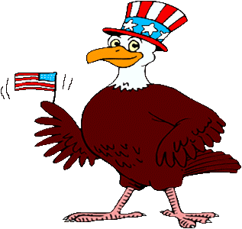
-Mrs. Kovacs & Mrs. Opie :)

